ACTIVITÉ**: CONSTRUCTION D’UN ENCLOS**

A-

**SITUATION** :

Monsieur Duquesnoy n’a pas fait vacciner à temps son pitbull Dudule et il doit accueillir ses petits enfants pour le week-end. Il prend la décision de construire un enclos rectangulaire.

Il dispose de 21 mètres de grillage qu’il imagine utiliser ainsi : le mur du jardin formera un côté de l’enclos et le grillage les 3 autres côtés.

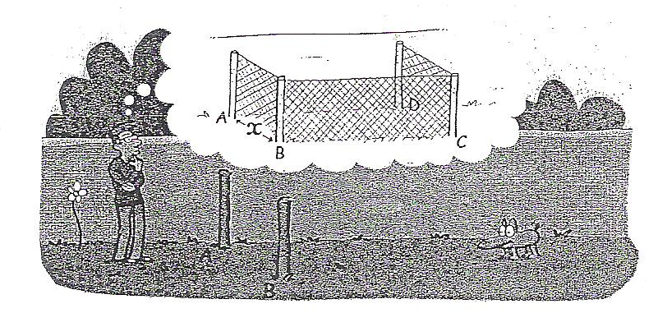

Pour cela, il a placé un premier piquet en A. Il hésite maintenant sur l’emplacement du piquet B.

**PROBLEMATIQUE : Où doit-il planter le piquet B afin que Dudule ait le maximum d’espace dans**

**son enclos ?**

|  |  |  |  |  |  |  |  |  |  |  |  |  |  |  |  |  |  |  |  |  |  |  |  |  |  |  |  |  |  |  |  |  |  |  |  |  |  |  |  |  |  |  |  |
| --- | --- | --- | --- | --- | --- | --- | --- | --- | --- | --- | --- | --- | --- | --- | --- | --- | --- | --- | --- | --- | --- | --- | --- | --- | --- | --- | --- | --- | --- | --- | --- | --- | --- | --- | --- | --- | --- | --- | --- | --- | --- | --- | --- |
| **PARTIE 1 :**   1. Proposer une démarche pour répondre à la problématique.   ……………………………………………………………………………………………………………………………………….  ……………………………………………………………………………………………………………………………………….  ……………………………………………………………………………………………………………………………………….  ……………………………………………………………………………………………………………………………………….  ……………………………………………………………………………………………………………………………………….  ……………………………………………………………………………………………………………………………………….  ……………………………………………………………………………………………………………………………………….   1. Exécuter la démarche proposée.   ……………………………………………………………………………………………………………………………………….  ……………………………………………………………………………………………………………………………………….  ……………………………………………………………………………………………………………………………………….  ……………………………………………………………………………………………………………………………………….  ……………………………………………………………………………………………………………………………………….  ……………………………………………………………………………………………………………………………………….  ……………………………………………………………………………………………………………………………………….  ……………………………………………………………………………………………………………………………………….  ……………………………………………………………………………………………………………………………………….  ……………………………………………………………………………………………………………………………………….  ……………………………………………………………………………………………………………………………………….  ……………………………………………………………………………………………………………………………………….  ……………………………………………………………………………………………………………………………………….  ……………………………………………………………………………………………………………………………………….  ……………………………………………………………………………………………………………………………………….  ……………………………………………………………………………………………………………………………………….  ……………………………………………………………………………………………………………………………………….   1. Répondre à la problématique   ……………………………………………………………………………………………………………………………………….  ……………………………………………………………………………………………………………………………………….  ……………………………………………………………………………………………………………………………………….  ……………………………………………………………………………………………………………………………………….  ……………………………………………………………………………………………………………………………………….  ……………………………………………………………………………………………………………………………………….  ………………………………………………………………………………………………………………………………………. | |  |  |  | | --- | --- | --- | | S’approprier | | | | 0 | 1 | 2 |  |  |  |  | | --- | --- | --- | | Analyser- Raisonner | | | | 0 | 1 | 2 |  |  |  |  | | --- | --- | --- | | Communiquer | | | | 0 | 1 | 2 |  |  |  |  | | --- | --- | --- | | S’approprier | | | | 0 | 1 | 2 |  |  |  |  | | --- | --- | --- | | Réaliser | | | | 0 | 1 | 2 |  |  |  |  | | --- | --- | --- | | Valider | | | | 0 | 1 | 2 |  |  |  |  | | --- | --- | --- | | Communiquer | | | | 0 | 1 | 2 | |
| **PARTIE 2 :**   1. Exprimer en fonction de $x$ la longueur BC, sachant que AB = .   ……………………………………………………………………………………………………………………………………….  ……………………………………………………………………………………………………………………………………….  ……………………………………………………………………………………………………………………………………….   1. Exprimer l’aire $A\left(x\right)$ de l’enclos en fonction de .   ……………………………………………………………………………………………………………………………………….  ……………………………………………………………………………………………………………………………………….  ……………………………………………………………………………………………………………………………………….  Appel**Appel n°1**  ***Faire vérifier votre expression au professeur***  **PARTIE 3 : Méthode algébrique**  **Quelle est l’aire la plus grande ?**   1. Compléter le tableau de valeurs suivant :  |  |  |  |  |  |  |  |  |  |  |  | | --- | --- | --- | --- | --- | --- | --- | --- | --- | --- | --- | |  | 1 | 2 | 3 | 4 | 5 | 6 | 7 | 8 | 9 | 10 | |  |  |  |  |  |  |  |  |  |  |  |  1. Repérer la valeur de l’aire qui vous semble la plus grande.   ……………………………………………………………………………………………………………………………………….  ……………………………………………………………………………………………………………………………………….  **Est-ce vraiment la valeur la plus grande ?**   1. Compléter le tableau de valeurs suivant :  |  |  |  |  |  |  | | --- | --- | --- | --- | --- | --- | |  | 4,9 | 5 | 5,1 | 5,2 | 5,3 | |  |  |  |  |  |  |  1. Compléter la phrase suivante :   La valeur la plus grande de l’aire est telle que : | |  |  |  | | --- | --- | --- | | S’approprier | | | | 0 | 1 | 2 |  |  |  |  | | --- | --- | --- | | S’approprier | | | | 0 | 1 | 2 |  |  |  |  | | --- | --- | --- | | Réaliser | | | | 0 | 1 | 2 |  |  |  |  | | --- | --- | --- | | S’approprier | | | | 0 | 1 | 2 |  |  |  |  | | --- | --- | --- | | Réaliser | | | | 0 | 1 | 2 |  |  |  |  | | --- | --- | --- | | Valider | | | | 0 | 1 | 2 | |
| **PARTIE 4 : Méthode graphique**   1. Représenter graphiquement, dans le repère ci-dessous, la fonction $A(x)$ en utilisant le tableau de la question 1, partie 3.      1. Repérer pour quelle valeur de $x$ l’aire semble-t-elle la plus grande ?   ……………………………………………………………………………………………………………………………………….  ……………………………………………………………………………………………………………………………………….  ……………………………………………………………………………………………………………………………………….   1. Ouvrir le logiciel Géogébra et représenter la fonction . 2. A l’aide des fonctionnalités du logiciel, déterminer la valeur exacte de $x$ pour laquelle l’aire est la plus grande.   ……………………………………………………………………………………………………………………………………….  ……………………………………………………………………………………………………………………………………….   1. Répondre à la problématique.   ……………………………………………………………………………………………………………………………………….  ……………………………………………………………………………………………………………………………………….  ……………………………………………………………………………………………………………………………………….  ……………………………………………………………………………………………………………………………………….  ……………………………………………………………………………………………………………………………………….  ………………………………………………………………………………………………………………………………………. | |  |  |  | | --- | --- | --- | | Réaliser | | | | 0 | 1 | 2 |  |  |  |  | | --- | --- | --- | | Analyser | | | | 0 | 1 | 2 |  |  |  |  | | --- | --- | --- | | Réaliser | | | | 0 | 1 | 2 |  |  |  |  | | --- | --- | --- | | Analyser | | | | 0 | 1 | 2 |  |  |  |  | | --- | --- | --- | | Valider | | | | 0 | 1 | 2 |  |  |  |  | | --- | --- | --- | | Communiquer | | | | 0 | 1 | 2 | |

|  |  |  |  |  |  |
| --- | --- | --- | --- | --- | --- |
| **BILAN** | **S'approprier** | **Analyser Raisonner** | **Réaliser** | **Valider** | **Communiquer** |
| **%** |  |  |  |  |  |